**Cloud Computing**

**Assignment: 1**

**Submitted By:** Seerat Fatima

**Registration.no:** 2023-BSE-060

**Section:** 5B

**Submitted To:** Sir Waqas Saleem

**Task List**

* **Task 1: Run Gitea in Codespace and Create an Initial Repo**
* **Task 2: Mirror README.md from Gitea to GitHub**
* **Task 3: Use Git LFS for Large Files**
* **Task 4: Create a Portfolio/CV with GitHub Pages**

**Task 1:**

**Screenshot of your Gitea repository (showing README listing names & roll numbers)**

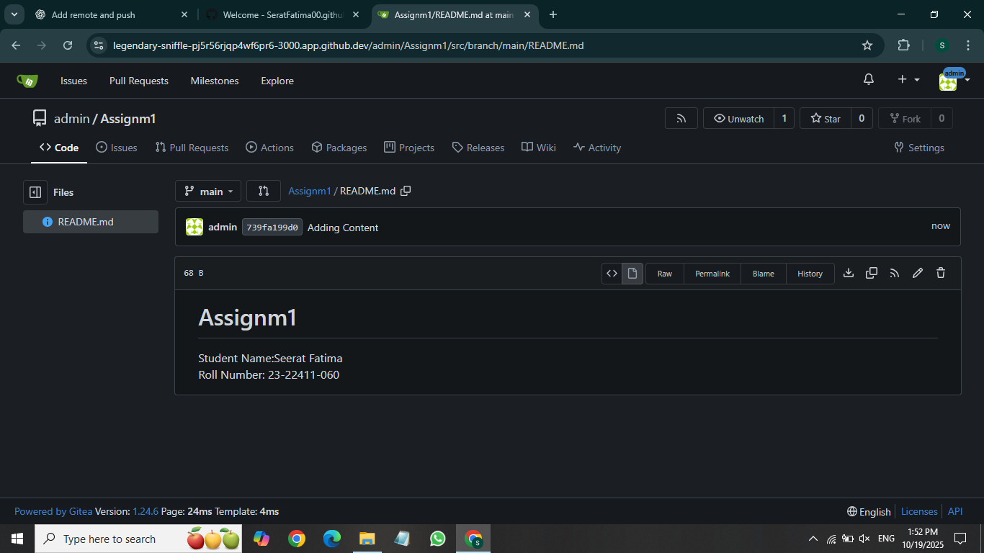

**Task:2**

**GitHub assignment 1 repo link (with README and large files)**

**Link:**

**<https://github.com/SeratFatima00/assignment1/commit/9b70f435054b21d32c0d2afd7210f8a47d1bf87d>**

**Task 3:**

**Screenshot or output of git remote -v showing both remote**

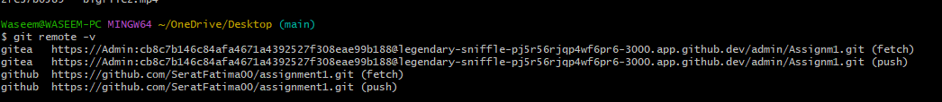

**Task 4:**

**GitHub Pages link to your CV/portfolio**

<https://seratfatima00.github.io/>